Joint Declaration
of the First China-Italy Finance Dialogue
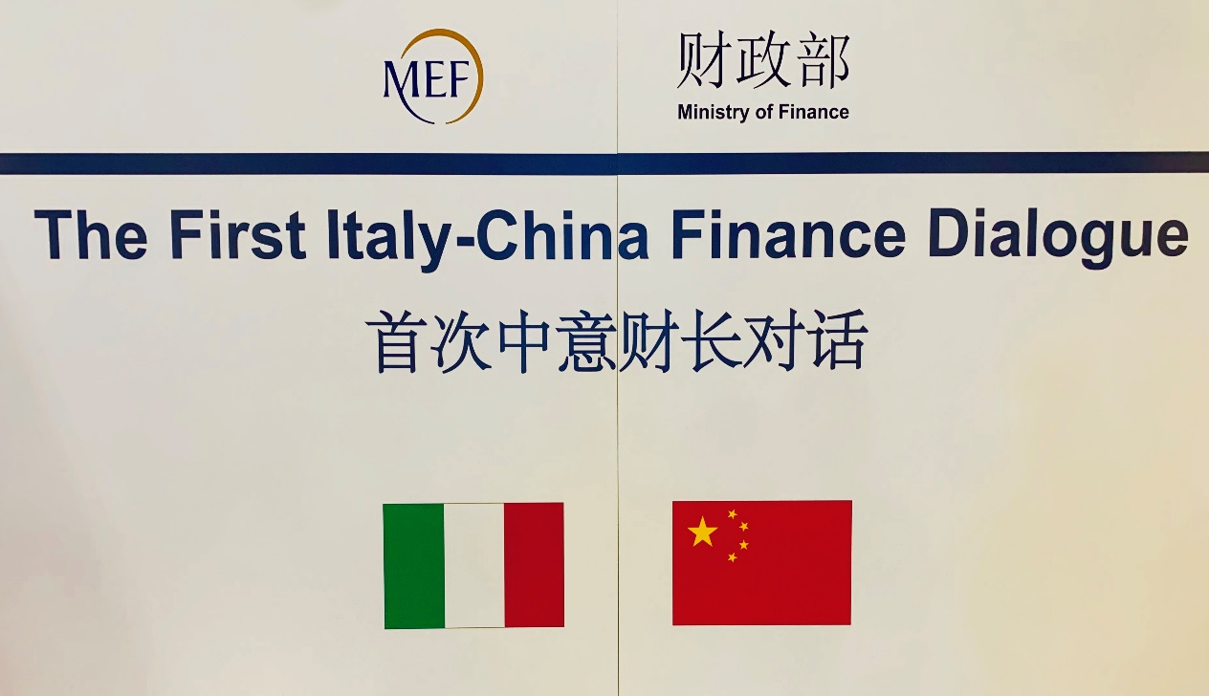

1. With a view to implementing the important consensus reached in the Joint Communiqué of the People's Republic of China and the Republic of Italy on Strengthening the Comprehensive Strategic Partnership agreed by the two Heads of State on March 23, 2019 on the "China-Italy Finance Ministers Dialogue Mechanism" and the agreement reached in the Memorandum of Understanding for the China-Italy Finance Dialogue signed by the two sides on November 29, 2018, the Minister of the Economy and Finance of the Italian Republic, Giovanni Tria and the Minister of Finance of the People’s Republic of China, Liu Kun jointly held the First China-Italy Finance Dialogue in Milan, Italy on July 10, 2019. Both sides acknowledge that, within the framework of the China-Italy Comprehensive Strategic Partnership, the dialogue serves the purpose of promoting bilateral exchanges and mutually beneficial cooperation, deepening engagement and fostering mutual benefits in economic and financial areas and promoting a closer China-Italy bilateral relationship.

2. Both sides reaffirm their commitment to deepen and broaden bilateral economic and financial relations by enhancing macroeconomic policy coordination and strengthening communication and cooperation on economic and financial issues of mutual interest. Both sides commit to promote a stable, fair, non-discriminatory and transparent business environment and a level playing field, to enable continued growth of bilateral trade and investment.

3. Both sides reaffirm their commitment to uphold the rules-based international economic system, to support multilateralism and the multilateral trading system with the WTO at its core, and to foster participation in the reform of global economic governance with a view to promoting high-quality, strong, sustainable, balanced and inclusive growth, improving living standards and boosting employment. Both sides will deepen the bilateral cooperation in the context of multilateral frameworks including the G20, the International Monetary Fund, and multilateral developments banks, such as the World Bank and the Asian Infrastructure Investment Bank (AIIB), with a view to promote an open world economy and sustainable development.

4. Italy and China support maintaining a strong, quota based and adequately resourced IMF to preserve its role at the center of the global financial safety net and agree to complete the IMF 15th General Reviews of Quotas by the Annual Meeting in 2019. They reaffirm that any realignment of the quota shares is expected to result in increased quota shares for dynamic economies in line with their relative positions in the world economy and hence likely in an increase in the share of emerging markets and developing countries as a whole. Both sides will continue to promote the implementation of the World Bank capital package.

5. Both sides recognize and support the ongoing work of the Paris Club, as the principal international forum for restructuring official bilateral debt, towards the broader engagement of emerging creditors. Creditor coordination is important for ensuring timely and effective debt restructurings when borrowers enter distress.

6. Both sides agree to enhance communication and cooperation on fiscal and tax policies in the spirit of mutual learning, exchanging experiences on budget management, taxation, accounting and audit supervision, social protection. Both sides agree to undertake joint studies or seminars on fiscal policy issues, such as ageing society and SMEs.

7. Both sides agree to strengthen cooperation in the financial market, promote two-way market access, and support their qualified financial institutions to expand business in each other's market. Both sides welcome financial institutions from each other to enter their securities, insurance, wealth management including custody services and futures markets in line with the regulatory framework currently or prospectively in force. Italy welcomes China’s commitments to open-up the financial sector and the implementation of related measures including allowing foreign business to own up to 51% of shares in securities, futures and life insurance joint ventures and phase out the cap in 2020. China welcomes Italy’s participation in the opening-up process of its financial market. Both sides welcome the first Panda Bond to be issued by a qualified Italian financial institution.

8. Both sides are committed to maintaining a favorable investment regulatory environment in order to boost two-way investments to promote economic growth and job creation. Both sides will continue to explore the possibility of setting up joint investment funds and other innovative financing instruments under the aegis of the China-Italy Finance Dialogue.

9. Both sides agree to deepen financial regulatory cooperation in banking, securities and insurance sectors, as well as in cross-border audit supervision. Both sides recognize the effective and consolidated technical cooperation and collaboration between the Central Banks, at the bilateral level as in the multilateral fora. Both sides support the signing of the MOU between CBIRC and IVASS on insurance supervision cooperation. Both sides will facilitate the activity of qualified banks within the applicable regulatory and supervisory framework.

10. Both sides will promote communication and cooperation on areas such as Inclusive Finance, FinTech and Green Finance, commit to working together under the Central Banks and Supervisors Network for Greening the Financial System (NGFS) and encourage signing of the “Green Investment Principles for the Belt and Road” by financial institutions from both countries.

11. Both sides agree to hold the China-Italy Joint Financial Forum under the China-Italy Finance Dialogue Mechanism when necessary, so as to promote financial market cooperation. Both sides support their financial institutions to seek partnership, promoting information exchange and investment cooperation.

12. Both sides commit to implement the Memorandum of Understanding between the two governments on jointly promoting the development of the Belt and Road, acknowledging the great potential of the Belt and Road Initiative in promoting interconnection and exchanges. Both sides will identify possible synergies between the BRI and the EU Strategy on Connecting Europe and Asia and explore opportunities to deepen pragmatic project cooperation.

13.Both sides support financial institutions from both countries to enhance financial cooperation and innovation, so to provide long-term, stable, diversified and sustainable financing support to their companies engaged in the Belt and Road and third-party market cooperation in line with market principles. Both sides support setting up a cooperation mechanism between their Export Credit Agencies (ECAs) and leading enterprises and financial institutions of the two countries to provide tailored financing-insurance solutions for cooperation in third market. In this regard, both sides welcome the signing of the MOUs of Export–Import Bank of China with Export Credit Agency of Italy (SACE) and UniCredit respectively and the implementation of the MOU between China Export & Credit Insurance Corporation (SINOSURE) and SACE.

14. Both sides recognize the importance of infrastructure for growth and development. Despite great efforts worldwide, the infrastructure investment gap remains significant in developing countries. In this context, both sides welcome the important progress made by the Asian Infrastructure Investment Bank (AIIB) and expect the AIIB to continue expanding its business and enhance international influence according to high standards. Both sides agree to strengthen their coordination and cooperation in the framework of AIIB and jointly explore project and third market cooperation opportunities.

15. Both sides support ongoing efforts to establish the Multilateral Cooperation Center for Development Finance (MCDF) with the aim to create a platform for bringing together international financial institutions, governments of developing countries and other development partners. By facilitating information sharing, capacity building and project preparation, the MCDF is expected to foster high-quality infrastructure and to promote the use of best practices and international standards built on the experience of the international financial institutions involved in the initiative. Subject to continuing discussions on governance, project standards, development impact and availability of dedicated budgetary resources, Italy will consider supporting the MCDF Financing Facility.

16. Both sides look forward to the 2nd China-Italy Finance Dialogue in China.

